# Numerical Results and Inferences

## Work on Survey Data (PHQ-9, PSS, Loneliness Scale)(Reproduced)

Got the total score of all participants in the survey data for pre and post semester surveys.

Compared pre and post semester scores using mean and standard deviation.

### PHQ-9

Consists of 9 questions with 0-3 answer scale each.

|  |  |  |  |  |  |
| --- | --- | --- | --- | --- | --- |
| Depression severity | minimal | minor | moderate | Moderately Severe | severe |
| Score | 1-4 | 5-9 | 10-14 | 15-19 | 20-27 |

|  |  |  |
| --- | --- | --- |
| Depression | Pre Semester | Post Semester |
| Mean | 5.521739 | 6.263158 |
| Standard Deviation | 4.612732 | 5.838753 |

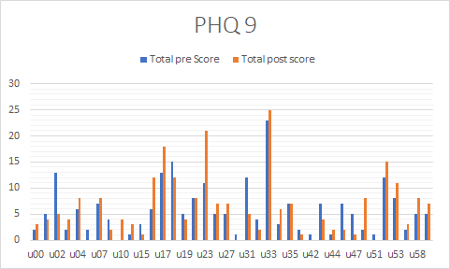

### Perceived Stress Scale

Consists of 10 questions with 0-4 answer scale each.

|  |  |  |  |
| --- | --- | --- | --- |
| Stress Scale | low | moderate | high |
| Score | 0-13 | 14-26 | 27-40 |

|  |  |  |
| --- | --- | --- |
| PSS | Pre Semester | Post Semester |
| Mean | 18.42 | 18.9 |
| Standard Deviation | 6.8 | 7.1 |

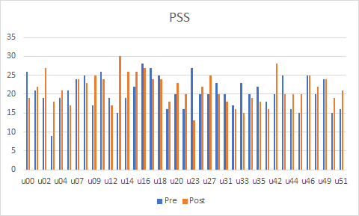

### Loneliness Scale

Consists of 20 questions with 1-4 answer scales each.

Higher the score, higher is the loneliness degree.

|  |  |  |
| --- | --- | --- |
| Loneliness Scale | Pre Semester | Post Semester |
| Mean | 54.23941018 | 53.38824773 |
| Standard Deviation | 4.122988457 | 5.095484664 |

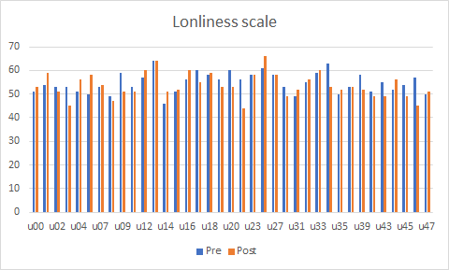

## Analysis Using ML Model

Used Linear Regression on the following data to understand the correlation.

These are the few independent variables which affect stress and depression the most.

1. Stress (EMA stress level), No. of calls
2. Stress, sleep hours
3. Stress, No. of deadlines
4. Stress, GPA
5. Stress, No. of active days on piazza
6. Depression (PHQ-9), No. of calls
7. Depression, sleep hours
8. Depression, No. of deadlines
9. Depression, GPA
10. Depression, No. of active days on piazza
11. Stress Level and Sleep Hours

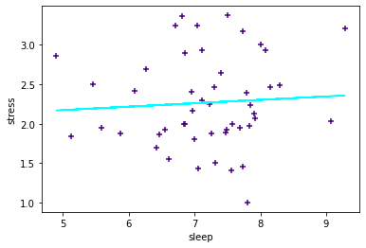

R^2 value = 0.004421174890784418

Intercept = 1.9565409234292304

Regression Coefficient = [0.04329695]

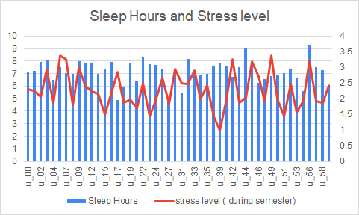

1. Stress Level and Call Logs

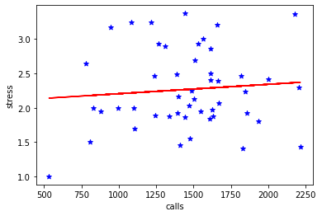

R^2 value = 0.007847019804197553

Intercept = 2.067857624375249

Regression Coefficient = [0.00013672]

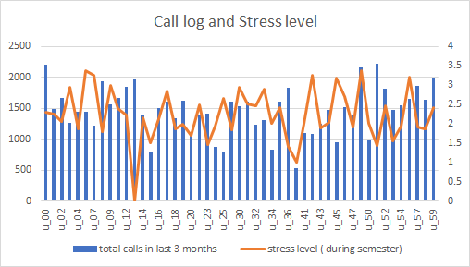

1. Stress Level and Deadlines

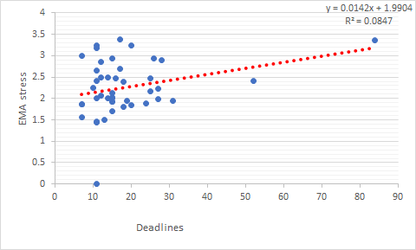

R^2 value = 0.084677

Intercept = 1.990443

Regression Coefficient = [0.014243]

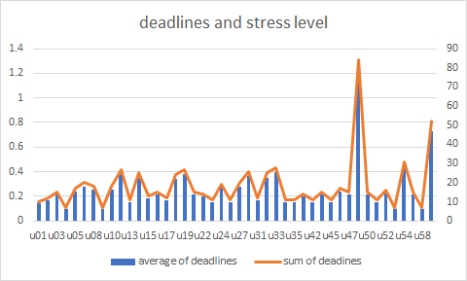

1. Stress Level and GPA

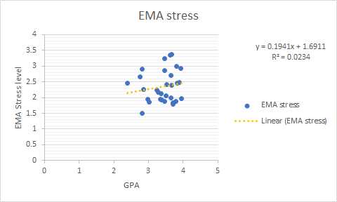

R^2 value = 0.023442

Intercept = 3.137086

Regression Coefficient = [0.120776]

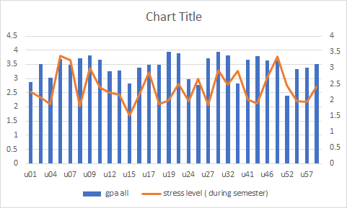

1. Stress level and Active days on Piazza

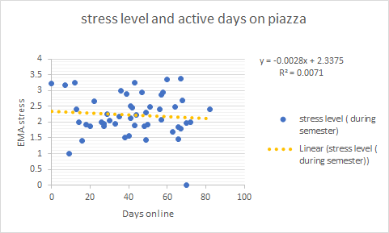

R^2 value = 0.0071

Intercept = 2.3375

Regression Coefficient = [-0.0028]

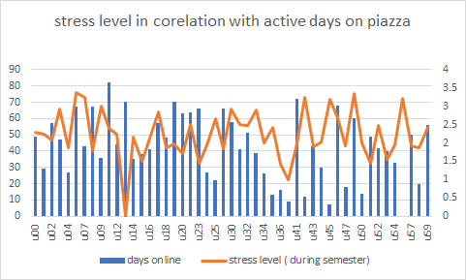

1. Depression and Sleep Hours

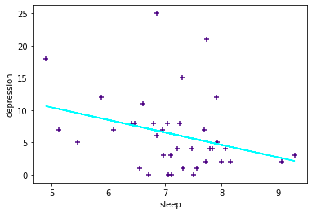

R^2 value = 0.093065

Intercept = 20.11626

Regression Coefficient = [-1.93661]

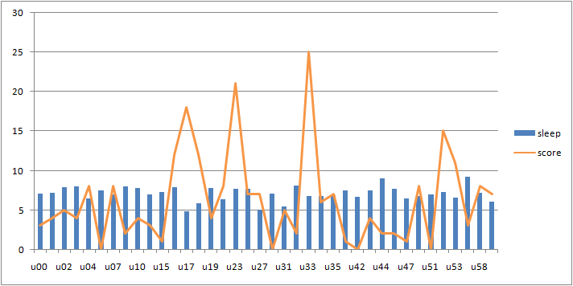

1. Depression and Call Logs

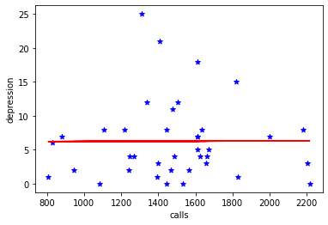

R^2 value = 1.5E-05

Intercept = 6.165855

Regression Coefficient = [0.005907]

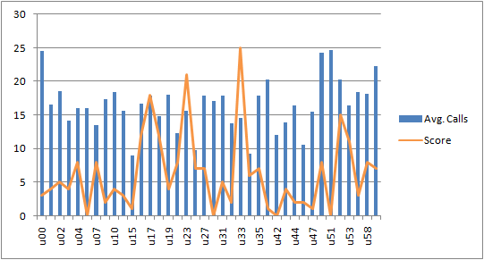

1. Depression and Deadlines

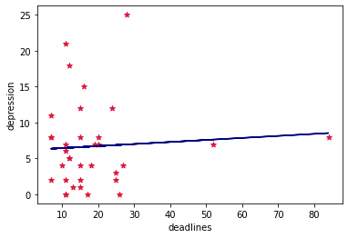

R^2 value = 0.004599

Intercept = 6.153554

Regression Coefficient = [0.028266]

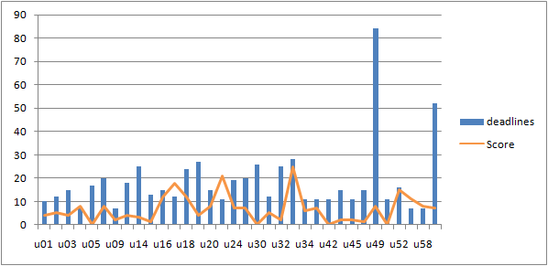

1. Depression and GPA

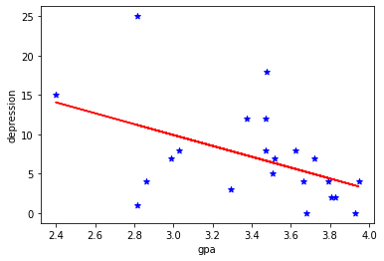

R^2 value = 0.22092

Intercept = 30.64107

Regression Coefficient = [-6.90694]

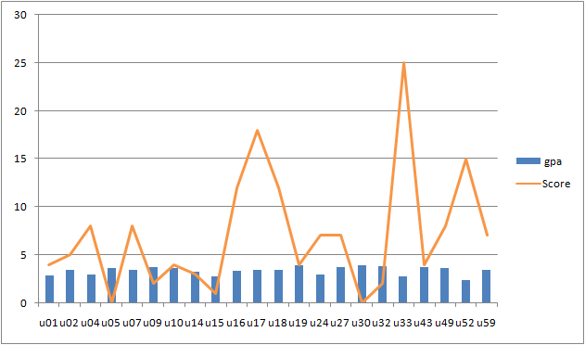

1. Depression and Active days on Piazza

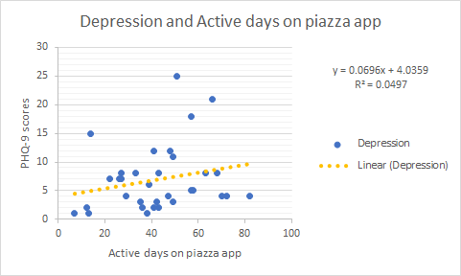

R^2 value = 0.0497

Intercept = 4.0359

Regression Coefficient = [0.0696]

